**Name: Aum Amar Shendge**

**Roll No: BTB17**

**PRN: 2122000270**

**Experiment No. 2: Implement the Inheritance, Functions and Methods in OODBMS**

1)

CREATE OR REPLACE TYPE Person2 AS OBJECT (

fname VARCHAR(20),

lname VARCHAR(20),

dob DATE,

MEMBER FUNCTION FullName RETURN VARCHAR,

MEMBER FUNCTION OnDate RETURN DATE

);

CREATE OR REPLACE TYPE BODY Person2 AS MEMBER FUNCTION FullName RETURN VARCHAR IS

BEGIN

RETURN fname || ' ' || lname;

END FullName;

MEMBER FUNCTION OnDate RETURN DATE IS

BEGIN

RETURN dob;

END OnDate;

END;

ALTER TYPE Person2 NOT FINAL;

CREATE OR REPLACE TYPE EMPOBJ UNDER Person2(

job VARCHAR(50),

sal NUMBER,

da NUMBER,

doj DATE,

MEMBER FUNCTION Earn RETURN NUMBER,

OVERRIDING MEMBER FUNCTION OnDate RETURN DATE

);

CREATE OR REPLACE TYPE BODY EMPOBJ AS

MEMBER FUNCTION Earn RETURN NUMBER IS

BEGIN

RETURN sal+da;

END Earn;

OVERRIDING MEMBER FUNCTION OnDate RETURN DATE IS

BEGIN

RETURN doj;

END OnDate;

END;

CREATE TABLE Employees(

Emp_id NUMBER primary key,

emp_details EMPOBJ

);

INSERT INTO Employees (Emp_id, emp_details)

VALUES (

1,

EMPOBJ('AUM', 'SHENDGE', TO_DATE('2023-10-09', 'YYYY-MM-DD'), 'Software Engineer ',100000,10000, TO_DATE('2003-10-09', 'YYYY-MM-DD'))

);

INSERT INTO Employees (Emp_id, emp_details)

VALUES (

2,

EMPOBJ('SUJAL', 'RAIBAGE', TO_DATE('2022-11-09', 'YYYY-MM-DD'), 'Software Engineer ',120000,10000, TO_DATE('2002-10-09', 'YYYY-MM-DD'))

);

INSERT INTO Employees (Emp_id, emp_details)

VALUES (

4,

EMPOBJ('NITIN', 'PATIL', TO_DATE('2019-12-01', 'YYYY-MM-DD'), 'Lead Developer', 140000, 15000, TO_DATE('1990-12-01', 'YYYY-MM-DD'))

);

INSERT INTO Employees (Emp_id, emp_details)

VALUES (

5,

EMPOBJ('PRIYA', 'DESHPANDE', TO_DATE('2020-08-25', 'YYYY-MM-DD'), 'QA Engineer', 110000, 12000, TO_DATE('1992-08-25', 'YYYY-MM-DD'))

);

1. Display employee Id, Employee Full Name, Employee Date of joining, Employee Date of Birth and Employee Earning for all employees.

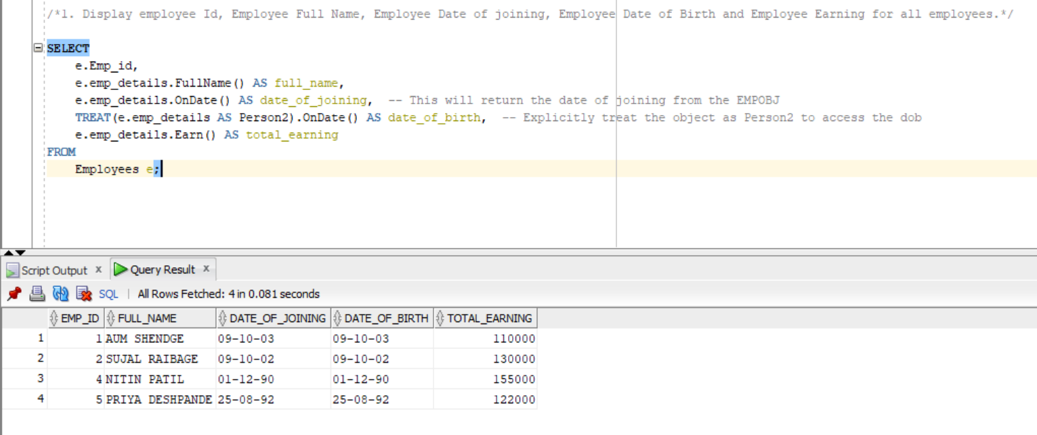

2)

CREATE TABLE People1 (  
    PersonID NUMBER GENERATED BY DEFAULT AS IDENTITY PRIMARY KEY,  
    FirstName VARCHAR2(50),  
    LastName VARCHAR2(50),  
    MiddleName VARCHAR2(50),  
    BirthDate DATE  
);  
  
CREATE TABLE Students1 (  
    StudentID NUMBER PRIMARY KEY,  
    Grade VARCHAR2(10),  
    Class VARCHAR2(50),  
    ParentID NUMBER,  
    FOREIGN KEY (StudentID) REFERENCES People1(PersonID),  
    FOREIGN KEY (ParentID) REFERENCES People1(PersonID)  
);  
  
CREATE TABLE Teachers1 (  
    TeacherID NUMBER PRIMARY KEY,  
    ClassesTaught VARCHAR2(100),  
    Skills VARCHAR2(100),  
    EmploymentInfo VARCHAR2(100),  
    FOREIGN KEY (TeacherID) REFERENCES People1(PersonID)  
);  
CREATE TABLE Parents1 (  
    ParentID NUMBER PRIMARY KEY,  
    StudentIDs VARCHAR2(100),  
    FOREIGN KEY (ParentID) REFERENCES People1(PersonID)  
);  
  
  
INSERT INTO People1 (FirstName, LastName, MiddleName, BirthDate) VALUES ('John', 'Doe', 'A', TO_DATE('1980-01-01', 'YYYY-MM-DD'));  
INSERT INTO People1 (FirstName, LastName, MiddleName, BirthDate) VALUES ('Jane', 'Smith', 'B', TO_DATE('1985-05-05', 'YYYY-MM-DD'));  
INSERT INTO People1 (FirstName, LastName, MiddleName, BirthDate) VALUES ('Michael', 'Johnson', 'C', TO_DATE('1990-10-10', 'YYYY-MM-DD'));  
INSERT INTO People1 (FirstName, LastName, MiddleName, BirthDate) VALUES ('Emily', 'Williams', 'D', TO_DATE('1995-12-15', 'YYYY-MM-DD'));  
  
  
  
INSERT INTO Students1 (StudentID, Grade, Class, ParentID) VALUES (1, 'A', 'Math', 2);  
INSERT INTO Students1 (StudentID, Grade, Class, ParentID) VALUES (2, 'B', 'Science', 1);    
INSERT INTO Students1 (StudentID, Grade, Class, ParentID) VALUES (3, 'A', 'History', 4);  
INSERT INTO Students1 (StudentID, Grade, Class, ParentID) VALUES (4, 'C', 'English', 3);  
  
  
INSERT INTO Teachers1 (TeacherID, ClassesTaught, Skills, EmploymentInfo) VALUES (1, 'Math, Algebra', 'Mathematics, Problem Solving', 'Full-time');  
INSERT INTO Teachers1 (TeacherID, ClassesTaught, Skills, EmploymentInfo) VALUES (2, 'Science, Physics', 'Science, Experimentation', 'Part-time');  
INSERT INTO Teachers1 (TeacherID, ClassesTaught, Skills, EmploymentInfo) VALUES (3, 'History, Social Studies', 'History, Research', 'Full-time');  
INSERT INTO Teachers1 (TeacherID, ClassesTaught, Skills, EmploymentInfo) VALUES (4, 'English, Literature', 'Literature, Writing', 'Contract');  
  
  
INSERT INTO Parents1 (ParentID, StudentIDs) VALUES (1, '2,3');    
INSERT INTO Parents1 (ParentID, StudentIDs) VALUES (2, '1');      
INSERT INTO Parents1 (ParentID, StudentIDs) VALUES (3, '4');      
INSERT INTO Parents1 (ParentID, StudentIDs) VALUES (4, '');      
  
SELECT * FROM People1;  
SELECT * FROM Students1;  
SELECT * FROM Teachers1;  
SELECT * FROM Parents1;

